|  |
| --- |
|  |
| Capstone Project Document |

**Bookaholic Social Network**

Report #2 – Screen Design

|  |  |  |
| --- | --- | --- |
| **Bookaholic Social Network** | | |
| **Group Members** | Pham Thi Huyen | SE03416 |
| Vu Hai Dang | SE03380 |
| Thai Thi Cam Van | SE03409 |
| Nguyen Thi Hai Yen | SE03171 |
| Chu Minh Hai | SE03143 |
| **Supervisor** | Mr. Nguyen Van Sang | |
| **Project code** | BSN | |

**- Hanoi, 10/2015 -**

# 1 Introduction

## Purpose

To ensure consistency and simplicity in detailed design across all displays within a product interface, as well as across other products used by the same users. Definitions, acronyms, abbreviations, references and overview of BSN website

## Definitions, Acronyms and Abbreviations

|  |  |  |
| --- | --- | --- |
| Abbreviations | Description | Comment |
| BSN | Bookaholic Social Network |  |
| Q&A | Question and Answer |  |

**Table 1.2: Definitions, Acronyms and Abbreviations**

## Overview

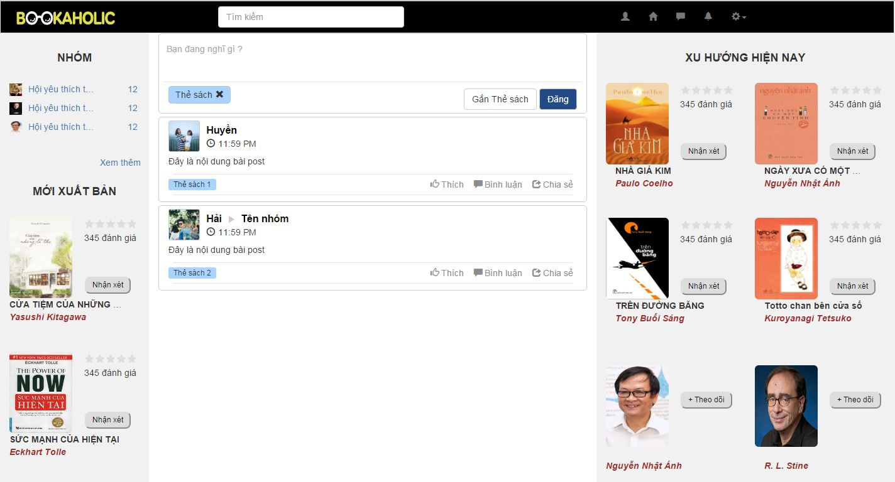

**Figure 1.3: Overview**

# Screen flow

## Register

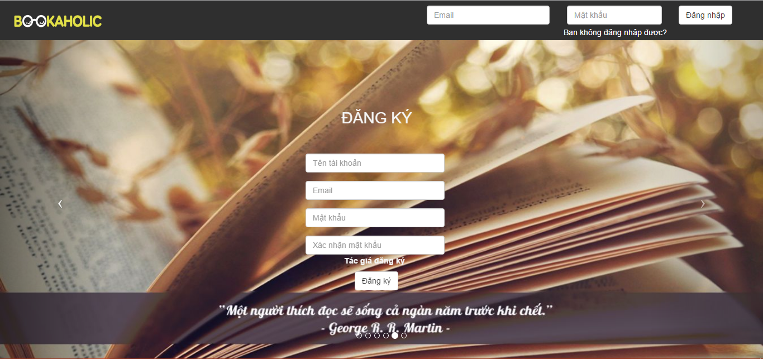

**Figure 2.1: Register screen**

|  |  |  |  |  |  |  |  |
| --- | --- | --- | --- | --- | --- | --- | --- |
| No | Field name | Field name in Vietnamese | Type | Require | Mandatory | Max-Length | Description |
|  | Register | Đăng ký | Label |  | Y |  | Display register form |
|  | Username | Tên tài khoản | Text box | Type | Y | 8-20 | Username of user |
|  | Email | Email | Textbox | Type | Y |  | Email of user |
|  | Password | Mật khẩu | Text box | Type | Y | 8-50 | Password of user |
|  | Sign up | Đăng ký | Button | Click | Y |  | User register a new account |

**Table 2.1: Register screen**

## Login



**Figure 2.2:Login screen**

|  |  |  |  |  |  |  |  |
| --- | --- | --- | --- | --- | --- | --- | --- |
| No | Field name | Field name in Vietnamese | Type | Require | Mandatory | Max-Length | Description |
|  | Email | Email | Text box | Type | Y |  | Email of registered user |
|  | Password | Mật khẩu | Text box | Type | Y | 8-20 | Password of registered user |
|  | Login | Đăng nhập | Button | Click | Y |  | Login |
|  | Forgot Password | Bạn không đăng nhập được? | Hyperlink | Click | Y |  | Resend password to user |

**Table 2.2: Login screen**

## Forget password

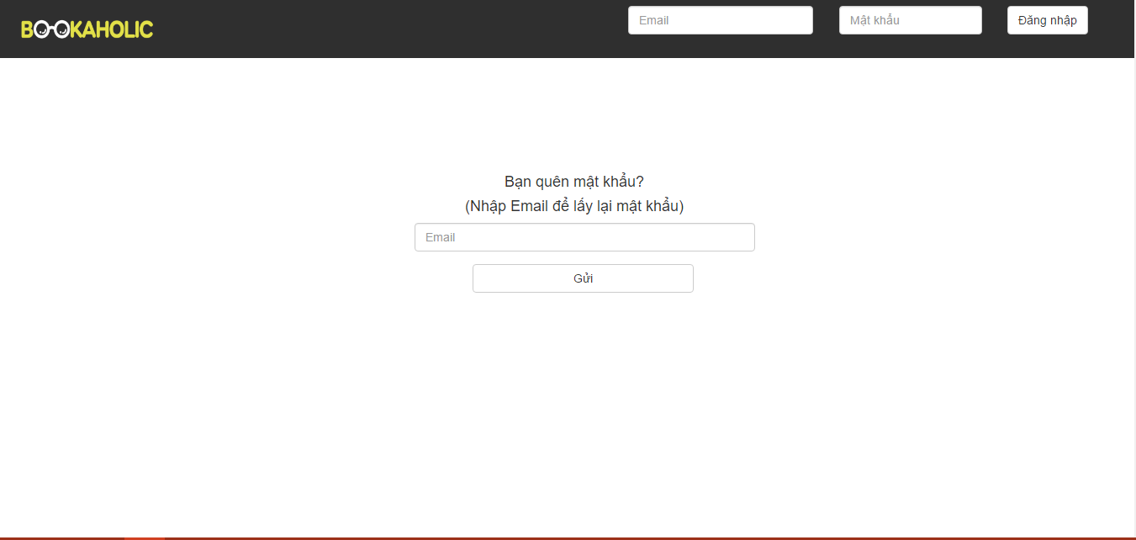

**Figure 2.3: Forgot password**

|  |  |  |  |  |  |  |  |
| --- | --- | --- | --- | --- | --- | --- | --- |
| No | Field name | Field name in Vietnamese | Type | Require | Mandatory | Max-Length | Description |
| 1 | Email | Khung Email | Text area |  | Y |  | Enter email to reset password. |
| 2 | Send | Gửi | Button | Click | Y |  | Send reset password request to system |

**Table 2.3: Forgot password**

## Homepage



**Figure 2.4: Homepage**

|  |  |  |  |  |  |  |  |
| --- | --- | --- | --- | --- | --- | --- | --- |
| No | Field name | Field name in Vietnamese | Type | Require | Mandatory | Max-Length | Description |
| 1 | Logo | Bookaholic | Image | Click | Y |  | Display homepage |
| 2 | Search box | Ô tìm kiếm | Textbox |  | Y |  | Search author, book. |
| 3 | Icon User | Trang cá nhân | Icon | Click | Y |  | Display user page |
| 4 | Icon Home | Trang chủ | Icon | Click | Y |  | Reload homepage |
| 5 | Icon comment | Tin nhắn | Icon | Click | Y |  | Displays list of messages |
| 6 | Icon bell | Thông báo | Icon | Click | Y |  | Displays list of notifications |
| 7 | Icon setting | Cài đặt | Icon | Click | Y |  | Display   * Create group * Setting * Logout |
| 8 | Create group | Tạo nhóm | Hyperlink | Click | Y |  | Display create group popup |
| 9 | Setting | Cài đặt | Hyperlink | Click | Y |  | Display edit information page |
| 10 | Logout | Đăng xuất | Hyperlink | Click | Y |  | Redirect to login page |
| 11 | Group | Nhóm | Hyperlink | Click | Y |  | Display group page |
| 12 | Username | Tên người dùng | Hyperlink | Click | Y |  | Display personal page |
| 13 | Book | Sách | Image | Click | Y |  | Show image’s book and name, author.  When click the image’s book then display book page. |
| 14 | Rating | Đánh giá | Icon |  | Y |  | Display average rating point |
| 15 | Button recommendation | Nhận xét | Button | Click | Y |  | Display the form to post comment about this book. |
| 16 | Form comment  (Click button recommendation) | Tên sách | Hyperlink | Click | Y |  | Display the new tag : Bookpage |
| Ảnh người dùng | Image |  | Y |  | Display the image of user |
| Khung nhập nội dung | Textarea | Type | Y |  | Allow enter feelings about the book |
| Thẻ sách | Text |  | Y |  | Display book tag |
| Nút post | Button | Click | Y |  | Posted 1 post comments on personal pages |
| 17 | Form recommendation | Khung nhập nội dung | Textarea | Type | Y |  | Allow enter feelings about the book |
| Gắn thẻ sách | Button | Click | Y |  | Display the input form to enter the booktag |
| Nút post | Button | Click | Y |  | Posted 1 post comments on personal pages |
| 18 | Review form | Ảnh đại diện người dùng | Image |  | Y |  | Display image of user |
| Tên người dùng | Text | Click | Y |  | Display the personal page |
| Thời gian đăng bài | Time |  | Y |  | Show time post comments |
| Nội dung | Text |  | Y |  | Show the comment of user about book |
| Thẻ sách | Text |  | Y |  | Display book tag |
| Thích | Button | Click | Y |  | Switch to liked status and increase the number of likes. |
| 19 | Author | Tác giả | Image | Click | Y |  | Show image’s author and name of author.  When click the image’s book then display author page |
| 20 | Button Follow | Nút theo dõi | Button | Click | Y |  | Switch to followed status |
| 21 | Publisher | Nhà xuất bản | Image |  | Y |  | Show image’s publisher and name of publisher, rating . |

**Table 2.4: HomePage**

## Personal page

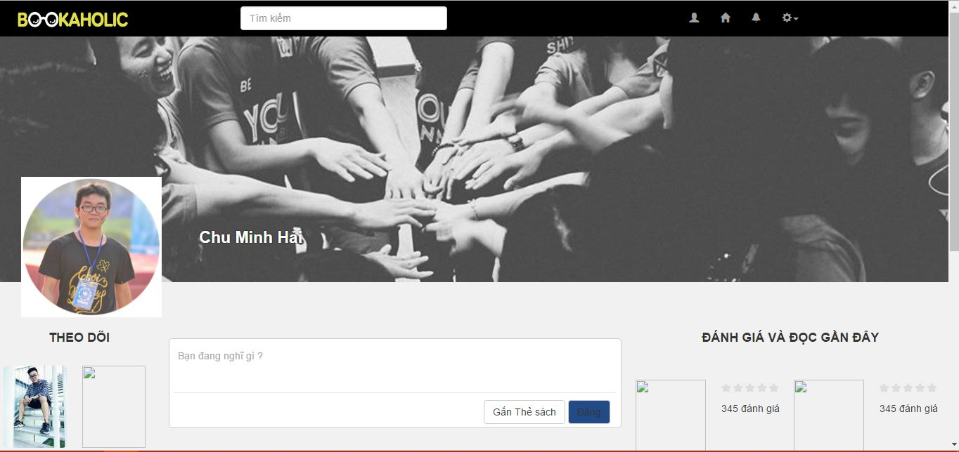

**Figure 2.5: Personal Page**

|  |  |  |  |  |  |  |  |
| --- | --- | --- | --- | --- | --- | --- | --- |
| No | Field name | Field name in Vietnamese | Type | Require | Mandatory | Max-Length | Description |
|  | Logo | Bookaholic | Image | Click | Y |  | Display homepage |
|  | Search box | Ô tìm kiếm | Textbox |  | Y |  | Search author, book. |
|  | Icon User | Trang cá nhân | Icon | Click | Y |  | Display user page |
|  | Icon Home | Trang chủ | Icon | Click | Y |  | Reload homepage |
|  | Icon comment | Tin nhắn | Icon | Click | Y |  | Displays list of messages |
|  | Icon bell | Thông báo | Icon | Click | Y |  | Displays list of notifications |
|  | Icon setting | Cài đặt | Icon | Click | Y |  | Display   * Create group * Setting * Logout |
|  | Create group | Tạo nhóm | Hyperlink | Click | Y |  | Display create group popup |
|  | Setting | Cài đặt | Hyperlink | Click | Y |  | Display edit information page |
|  | Logout | Đăng xuất | Hyperlink | Click | Y |  | Redirect to login page |
|  | Recommendation | Khung nhận xét | Text field |  | Y |  | Use to enter a recommendation |
|  | Tag a book | Gắn thẻ sách | Button | Click | Y |  | Click button to tag a book or tag an author |
|  | Post | Đăng | Button | Click | Y |  | Click to post a recommendation |
|  | Avatar | Ảnh đại diện | Image |  | Y |  | Avatar of user |
|  | Change avatar | Thay đổi ảnh đại diện | Hyperlink | Click | Y |  | Click to change avatar |
|  | Cover | Ảnh bìa | Image |  | Y |  | Cover of user |
|  | Change cover | Thay đổi ảnh bìa | Hyperlink | Click | Y |  | Click to change cover |
|  | Username | Tên người dùng | Hyperlink | Click | Y |  | Redirect to user page |
|  | Book’s image | Ảnh bìa sách | Image |  | Y |  |  |
|  | Book name | Tên sách | Hyperlink | Click | Y |  | Redirect to book page |

**Table 2.5: Personal Page**

## Edit profile

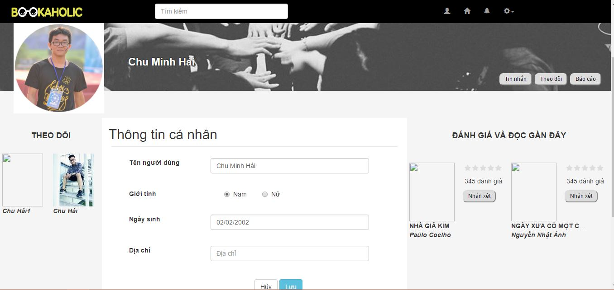

**Figure 2.6: Edit profile**

|  |  |  |  |  |  |  |  |
| --- | --- | --- | --- | --- | --- | --- | --- |
| No | Field name | Field name in Vietnamese | Type | Require | Mandatory | Max-Length | Description |
| 1 | Username | Tên người dùng | Text field |  | Y |  | Text field can be edited to change username |
| 2 | Gender | Giới tính | Radio buttons | Click | Y |  | Click to change gender of user |
| 3 | Date of birth | Ngày sinh | Text field |  | Y |  | Edit to change date of birth |
| 4 | Address | Địa chỉ | Text field |  | Y |  | Edit to change address |
| 5 | Cancel | Huỷ | Button | Click | Y |  | When click cancel button, all editing info will cancel |
| 6 | Save | Lưu | Button | Click | Y |  | Click to save all editing info |

**Table 2.6: Edit profile**

## Report user

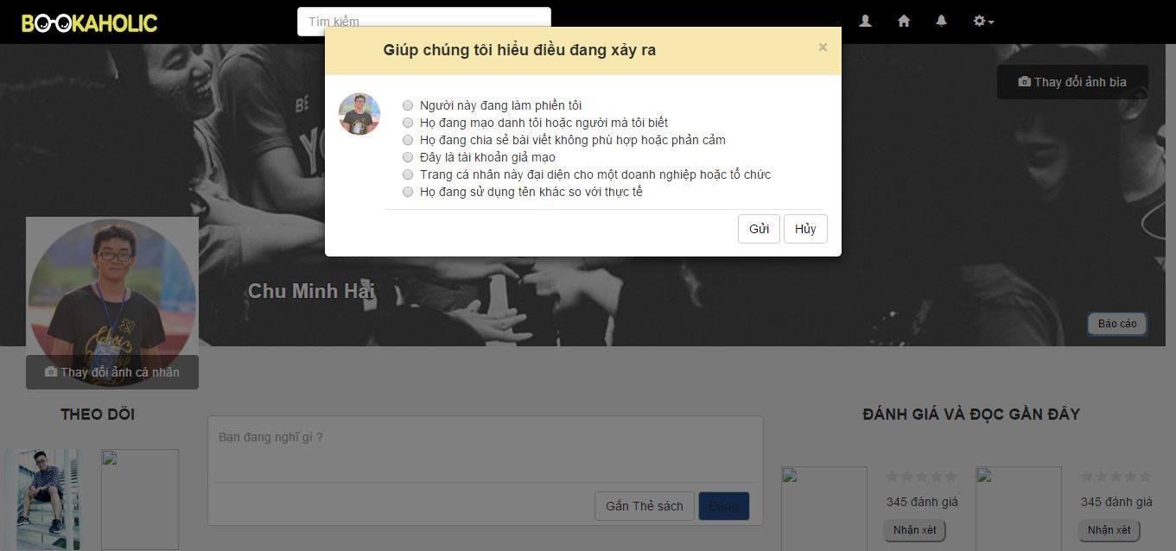

**Figure 2.7: Report user**

|  |  |  |  |  |  |  |  |
| --- | --- | --- | --- | --- | --- | --- | --- |
| No | Field name | Field name in Vietnamese | Type | Require | Mandatory | Max-Length | Description |
|  | Avatar | Ảnh đại diện | Image |  | Y |  | Avatar of reported user |
|  | Radio buttons | Người này đang làm phiền tôi | Label | Click | Y |  | List of reasons, click to choose a reason |
|  | Send | Gửi | Button | Click | Y |  | Click to send report to admin |
|  | Cancel | Hủy | Button | Click | Y |  | Cancel reporting, close popup |

**Table 2.7: Report user**

## Request to add books

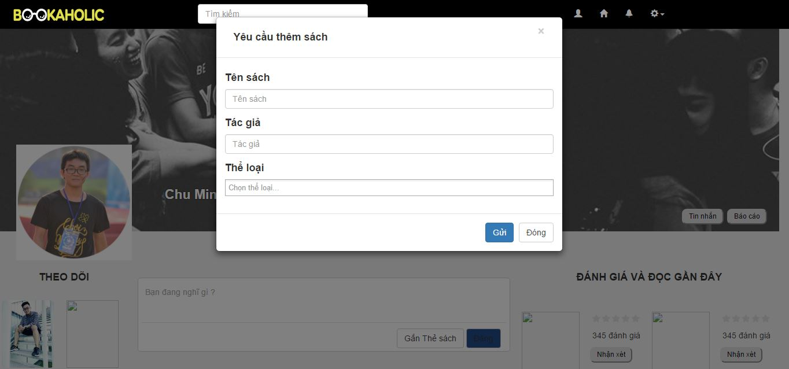

**Figure 2.8: Request to add books**

|  |  |  |  |  |  |  |  |
| --- | --- | --- | --- | --- | --- | --- | --- |
| No | Field name | Field name in Vietnamese | Type | Require | Mandatory | Max-Length | Description |
| 1 | Book’s name | Tên sách | Text field |  | Y |  | Request book’s name |
| 2 | Author | Tác giả | Text field |  | Y |  | Request book’s author |
| 3 | Category | Thể loại | Text field |  | Y |  | Request book’s category |
| 4 | Send | Gửi | Button |  | Y |  | When click, send request to admin |
| 5 | Close | Đóng | Button |  | Y |  | When click, close popup |

**Table 2.8: Request to add books**

## Create a group

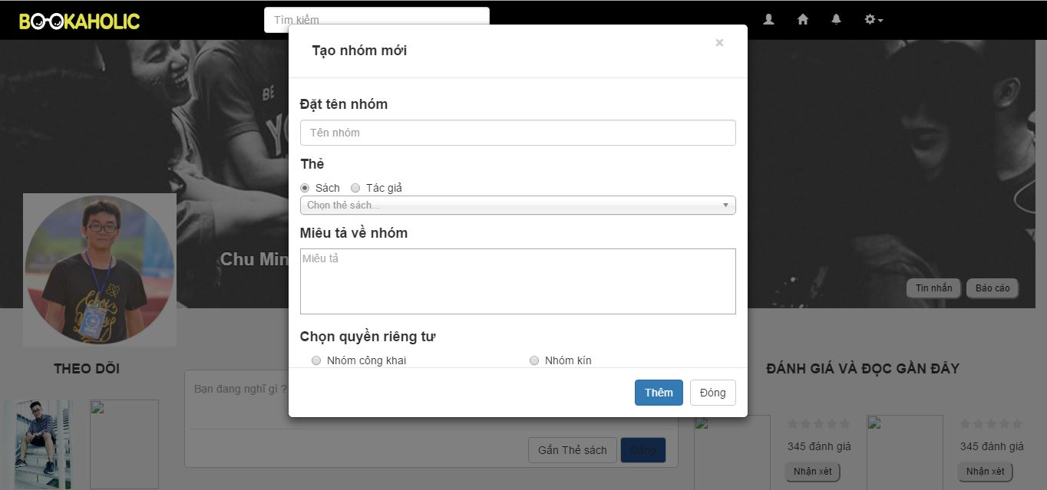

**Figure 2.9: Create a group**

|  |  |  |  |  |  |  |  |
| --- | --- | --- | --- | --- | --- | --- | --- |
| No | Field name | Field name in Vietnamese | Type | Require | Mandatory | Max-Length | Description |
| 1 | Name of group | Tên nhóm | Text field |  | Y |  |  |
| 2 | Book | Sách | Button | Click | Y |  |  |
| 3 | Author | Tác giả | Button | Click | Y |  |  |
| 4 | Category | Thể loại | Combo box | Click | Y |  |  |
| 5 | Description | Miêu tả | Text area |  | Y |  |  |
| 6 | Public group | Nhóm công khai | Radio button | Click | Y |  |  |
| 7 | Closed group | Nhóm kín | Radio button | Click | Y |  |  |
|  |  |  |  |  |  |  |  |

**Table 2.9: Create a group**

## Group page

### Group page-Conversation

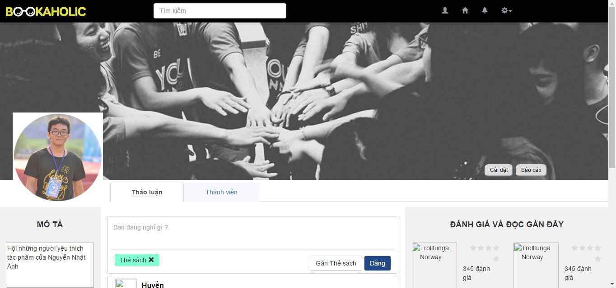

**Figure 2.10.1: Group Page-Conversation**

|  |  |  |  |  |  |  |  |
| --- | --- | --- | --- | --- | --- | --- | --- |
| No | Field name | Field name in Vietnamese | Type | Require | Mandatory | Max-Length | Description |
|  | Logo | Bookaholic | Image | Click | Y |  | Display homepage |
|  | Search box | Ô tìm kiếm | Textbox |  | Y |  | Search author, book. |
|  | Icon User | Trang cá nhân | Icon | Click | Y |  | Display user page |
|  | Icon Home | Trang chủ | Icon | Click | Y |  | Reload homepage |
|  | Icon comment | Tin nhắn | Icon | Click | Y |  | Displays list of messages |
|  | Icon bell | Thông báo | Icon | Click | Y |  | Displays list of notifications |
|  | Icon setting | Cài đặt | Icon | Click | Y |  | Display   * Create group * Setting * Logout |
|  | Create group | Tạo nhóm | Hyperlink | Click | Y |  | Display create group popup |
|  | Setting | Cài đặt | Hyperlink | Click | Y |  | Display edit information page |
|  | Logout | Đăng xuất | Hyperlink | Click | Y |  | Redirect to login page |
|  | Recommendation | Khung nhận xét | Text field |  | Y |  | Use to enter a recommendation |
|  | Description | Mô tả nhóm | Label |  | Y |  |  |
|  | Description’s content | Nội dung mô tả | Text area | Click | Y |  | Description about group |
|  | Group setting | Cài đặt | Button | Click | Y |  | When click, redirect to group setting page |
|  | Report group | Ảnh đại diện | Image |  | Y |  | Avatar of reported group |
| Người này đang làm phiền tôi | Label | Click | Y |  | List of reasons, click to choose a reason |
| Gửi | Button | Click | Y |  | Click to send report to admin |
| Hủy | Button | Click | Y |  | Cancel reporting, close popup |
|  | Post | Đăng | Button | Click | Y |  | Click to post a recommendation |
|  | Avatar | Ảnh đại diện | Image |  | Y |  | Avatar of group |
|  | Change avatar | Thay đổi ảnh đại diện | Hyperlink | Click | Y |  | Click to change avatar |
|  | Cover | Ảnh bìa | Image |  | Y |  | Cover of group |
|  | Change cover | Thay đổi ảnh bìa | Hyperlink | Click | Y |  | Click to change cover |
|  | Username | Tên người dùng | Hyperlink | Click | Y |  | Redirect to user page |
|  | Book’s image | Ảnh bìa sách | Image |  | Y |  |  |
|  | Book name | Tên sách | Hyperlink | Click | Y |  | Redirect to book page |

**Table 2.10.1: Group Page-Conversation**

### Group page-Members

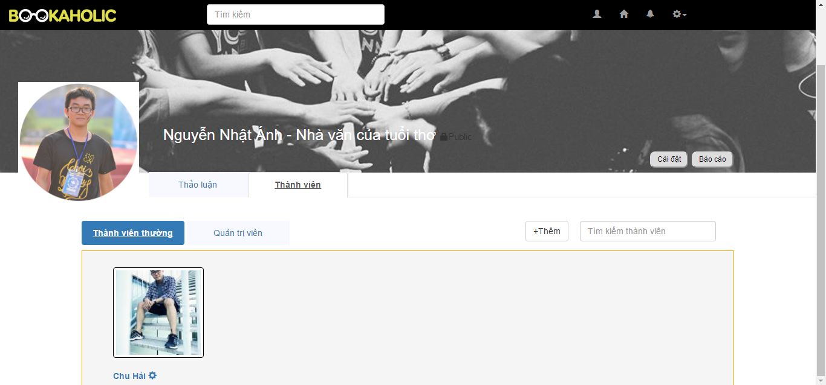

**Figure 2.10.2.1: Group Page-Members**

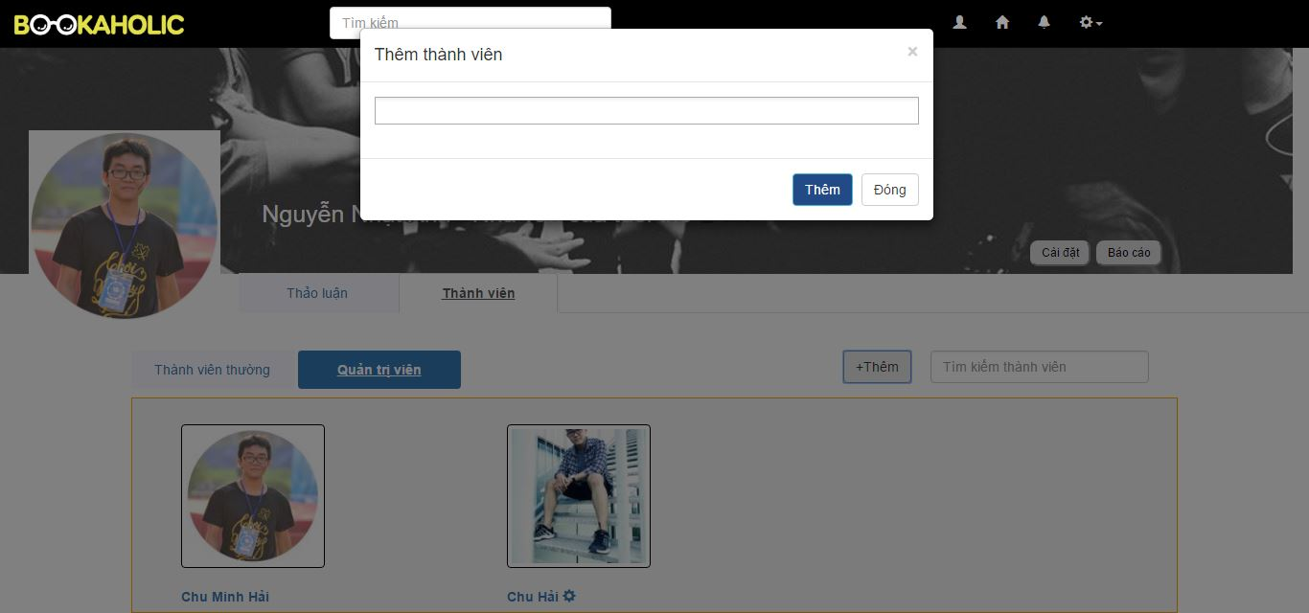

**Figure 2.10.2.2: Add new member**

|  |  |  |  |  |  |  |  |
| --- | --- | --- | --- | --- | --- | --- | --- |
| No | Field name | Field name in Vietnamese | Type | Require | Mandatory | Max-Length | Description |
|  | Search | Ô tìm kiếm | Search box | Click | Y |  | Search members |
|  | Add new member | Thêm thành viên mới | Button | Click | Y |  | Display popup with:  - Enter username text field  - Add button  - Close button |
| Nhập tên người dùng | Text field |  | Y |  | Enter a username to add to group |
| Nút thêm | Button |  | Y |  | When click, add selected user to group |
| Nút đóng | Button |  | Y |  | When click, cancel adding new member and close popup |
|  | Normal member | Ảnh đại diện của thành viên | Image |  | Y |  | Member’s avatar |
| Tên thành viên | Hyperlink | Click | Y |  | When click, redirect to member page |
| Biểu tượng cài đặt | Icon | Click | Y |  | When click, show modify popup:  - Set as an admin  - Remove from group |
|  | Modify popup | Thêm với tư cách quản lý | Hyperlink | Click | Y |  | Set member as an admin |
| Xóa khỏi nhóm | Hyperlink | Click | Y |  | Remove user from group. User no longer be as a member of group |
|  | Admin | Ảnh đại diện của quản trị viên | Image |  | Y |  | Admin’s avatar |
| Tên quản trị viên | Hyperlink | Click | Y |  | When click, redirect to user page |
| Biểu tượng cài đặt | Icon | Click | Y |  | When click, show modify admin popup:  - Remove as an admin  - Remove from group |
|  | Modify admin popup | Xóa với tư cách quản lý | Hyperlink | Click | Y |  | Remove admin right and become a member |
| Xóa khỏi nhóm | Hyperlink | Click | Y |  | Remove user from group. User no longer be as a member of group |

**Table 2.10.2: Group Page-Members**

## Setting group

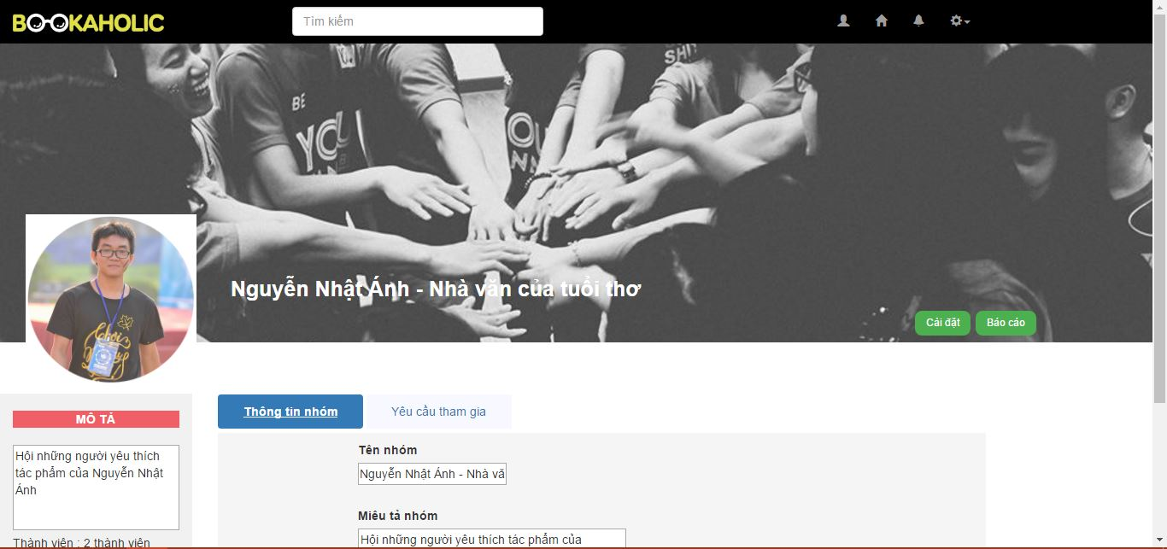

**Figure 2.11.1: Edit group**

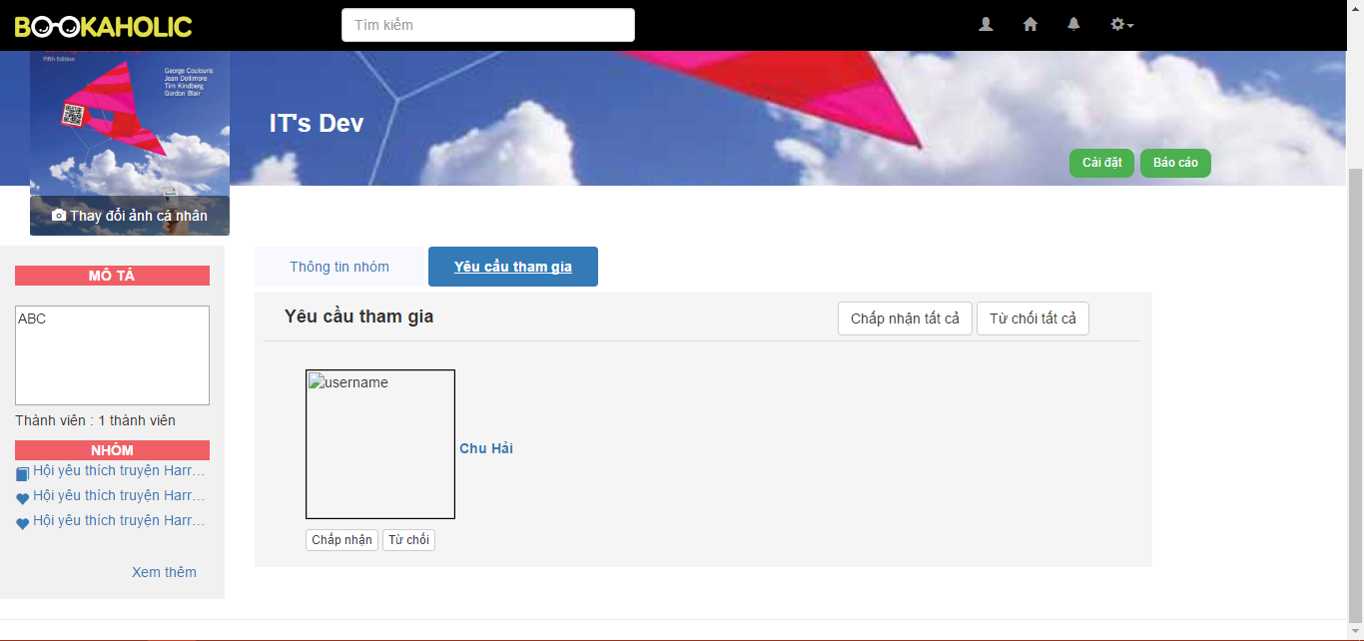

**Figure 2.11.2: Accept to join**

|  |  |  |  |  |  |  |  |
| --- | --- | --- | --- | --- | --- | --- | --- |
| No | Field name | Field name in Vietnamese | Type | Require | Mandatory | Max-Length | Description |
|  | Edit group tab | Tên nhóm | Hyperlink | Click | Y |  | Click to redirect to group page |
| Mô tả nhóm | Label |  | Y |  |  |
| Nội dung mô tả | Textarea | Click | Y |  | Description about group |
| Thông tin nhóm | Hyperlink | Click | Y |  | Group’s information tab |
| Yêu cầu tham gia | Hyperlink | Click | Y |  | Join-group request tab |
| Nhãn Tên nhóm | Label |  | Y |  |  |
| Tên nhóm | Text area |  | Y |  | Group name’s text area. Admin can edit to change |
| Nút radio | Button | Click | Y |  | Click to choose Public or Private Group’s type |
| Mô tả nhóm | Text area |  | Y |  | Group description’s text area. Admin can edit to change |
| Nút lưu | Button | Click | Y |  | When click, save and update all group’s info |
|  | Accept to join | Chấp nhận tất cả | Button | Click | Y |  | Accept all join-group requests |
| Từ chốt tất cả | Button | Click | Y |  | Denied all join-group requests |
| Tên người dùng | Hyperlink | Click | Y |  | When click, redirect to user page |
| Chấp nhận | Button | Click | Y |  | Accept chosen request |
| Từ chối | Button | Click | Y |  | Denied chosen request |

**Table 2.11: Setting group**

# Admin

## Login



**Figure 3.1: Login**

|  |  |  |  |  |  |  |  |
| --- | --- | --- | --- | --- | --- | --- | --- |
| No | Field name | Field name in Vietnamese | Type | Require | Mandatory | Max-Length | Description |
|  | Register | Đăng ký | Label |  | Y |  | Display register form |
|  | Username | Tên tài khoản | Text box | Type | Y | 20 | Username of Admin |
|  | Email | Email | Textbox | Type | Y |  | Email of Admin |
|  | Password | Mật khẩu | Text box | Type | Y | 50 | Password of Admin |

**Table 3.1: Login**

## User management

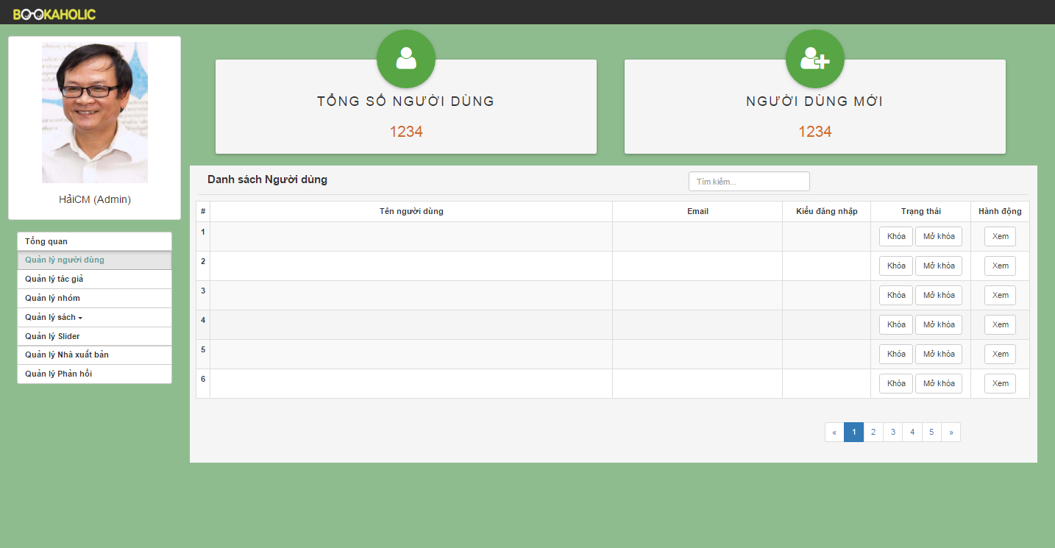

**Figure 3.2: User management**

|  |  |  |  |  |  |  |  |
| --- | --- | --- | --- | --- | --- | --- | --- |
| No | Field name | Field name in Vietnamese | Type | Require | Mandatory | Max-Length | Description |
| 1 | Total users | Tổng số người dùng | Label |  | Y |  | Total users registed |
| 2 | Total new users | Người dùng mới | Label |  | Y |  | Total new users |
| 3 | List user | Danh sách người dùng | Table |  | Y |  | List users  (User name, email, kind of login, status, action) |
| 4 | View button | Xem | Button | Click | Y |  | When click the view button then display user page. |

**Table 3.2: User management**

## Author management

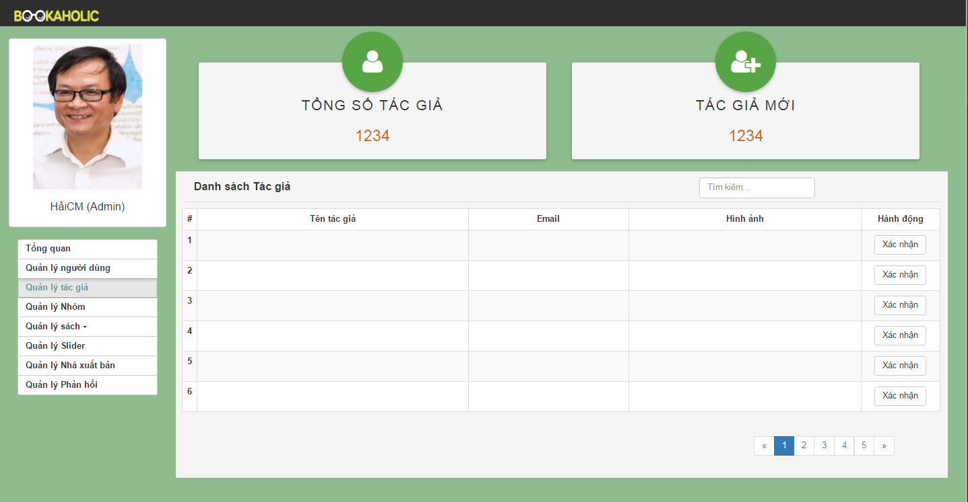

**Figure 3.3: Author Management**

|  |  |  |  |  |  |  |  |
| --- | --- | --- | --- | --- | --- | --- | --- |
| No | Field name | Field name in Vietnamese | Type | Require | Mandatory | Max-Length | Description |
| 1 | Total authors | Tổng số tác giả | Label |  | Y |  | Total authors registed |
| 2 | Total new authors | Tác giả mới | Label |  | Y |  | Total new authors |
| 3 | List author | Danh sách tác giả | Table |  | Y |  | List authors  (Author name, email, image, status, action) |
| 4 | Verify  button | Nút xác nhận | Butoon | Click | Y |  | Admin will confirm when author registed |

**Table 3.3: Author management**

## Group management

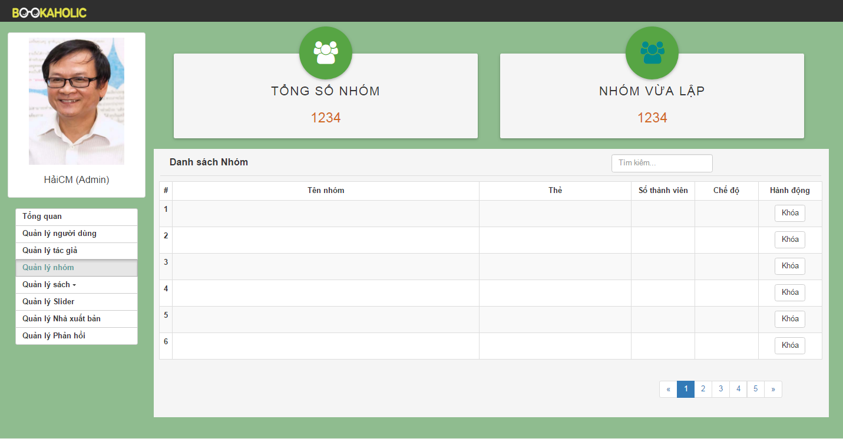

**Figure 3.4: Group Management**

|  |  |  |  |  |  |  |  |
| --- | --- | --- | --- | --- | --- | --- | --- |
| No | Field name | Field name in Vietnamese | Type | Require | Mandatory | Max-Length | Description |
| 1 | Total groups | Tổng số nhóm | Label |  | Y |  | Total groups |
| 2 | Total new groups | Tác giả mới | Label |  | Y |  | Total new groups |
| 3 | List group | Danh sách group | Table |  | Y |  | List groups  (Group name, tag book or tag author, number of member, public or private, action) |
| 4 | Lock button | Nút khóa | Button | Click | Y |  | Lock group |
|  |  |  |  |  |  |  |  |

**Table 3.4: Group Management**

## Book management

### Statistics books

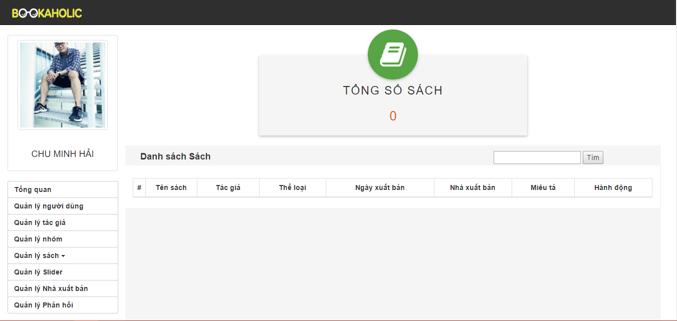

**Figure 3.5.1: Statistics books**

|  |  |  |  |  |  |  |  |
| --- | --- | --- | --- | --- | --- | --- | --- |
| No | Field name | Field name in Vietnamese | Type | Require | Mandatory | Max-Length | Description |
| 1 | Total books | Tổng số sách | Label |  | Y |  | Total books |
| 2 | Button Add book | Thêm sách mới | Button | Click | Y |  | When click the button add book then link to add book page.. |
| 3 | Search | Tìm kiếm | Textbox | Click | Y |  | Search about book |
| 4 | List book | Danh sách sách | Table |  | Y |  | List books (book’name, author, category, publishing date, action) |
| 5 | Edit button | Nút sửa | Button | Click | Y |  | When click button edit then appear popup edit book. |
| 6 | Delete button | Nút xóa | Button | Click | Y |  | When click button delete will this book deleted. |

**Table 3.5.1: Statistics books**

### Request add book

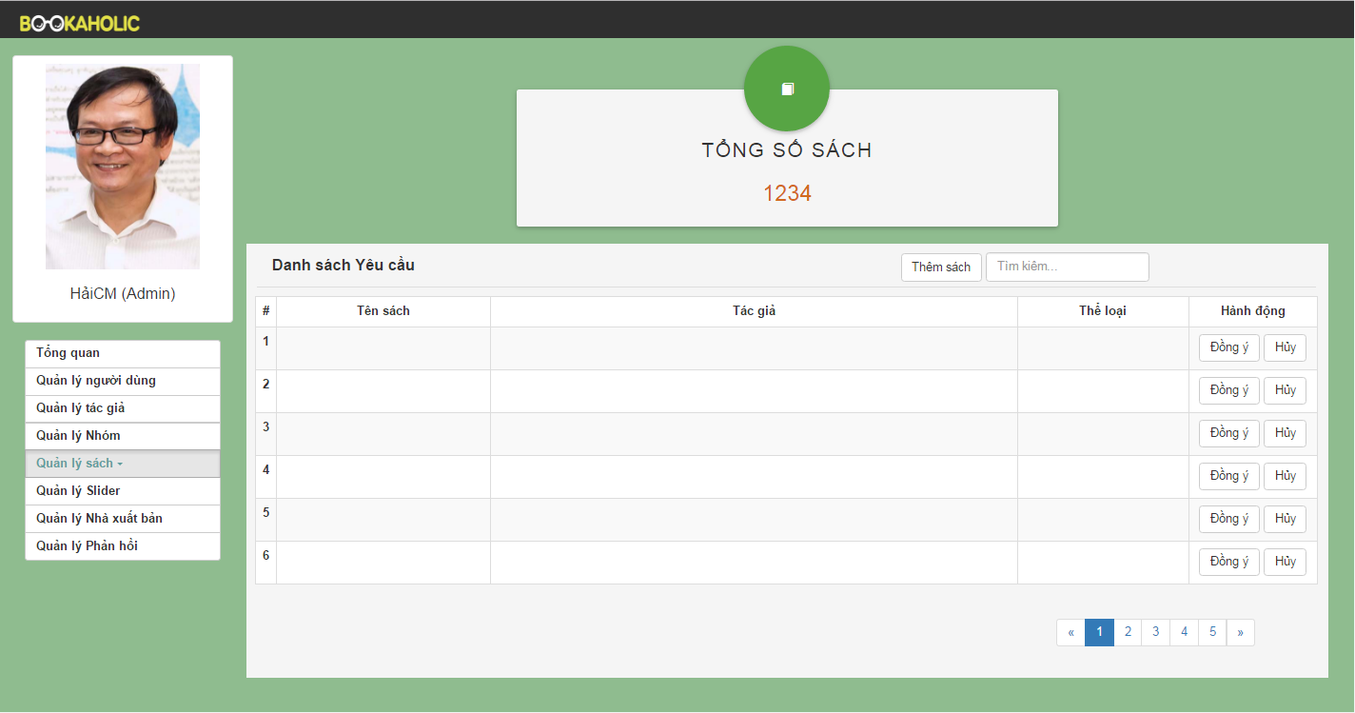

**Figure 3.5.2: Request add book**

|  |  |  |  |  |  |  |  |
| --- | --- | --- | --- | --- | --- | --- | --- |
| No | Field name | Field name in Vietnamese | Type | Require | Mandatory | Max-Length | Description |
| 1 | Total books | Tổng số sách | Label |  | Y |  | Total books |
| 2 | Button Add book | Thêm sách mới | Button | Click | Y |  | When click the button add book then link to add book page… |
| 3 | Search | Tìm kiếm | Textbox | Click | Y |  | Search about book |
| 4 | List book | Danh sách sách | Table |  | Y |  | List books (book’s name, author, category, publishing date, action). |
| 5 | Agree button | Nút đồng ý | Button | Click | Y |  | When click agree button, the new book will be added. |
| 6 | Button Cancel | Nút hủy | Button | Click | Y |  | When click cancel button , the book will be cancel. |

**Table 3.5.2: Request add book**

### Add a book

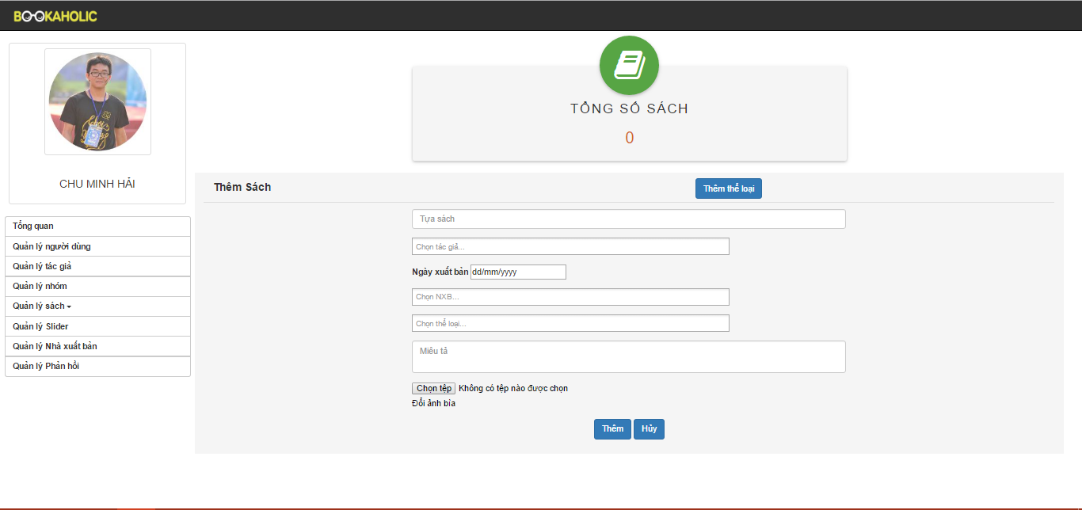

**Figure 3.5.3: Add a book**

|  |  |  |  |  |  |  |  |
| --- | --- | --- | --- | --- | --- | --- | --- |
| No | Field name | Field name in Vietnamese | Type | Require | Mandatory | Max-Length | Description |
| 1 | Total books | Tổng số sách | Label |  | Y |  | Total books |
| 2 | Button Add new category | Thêm thể loại | Text | Click | Y |  | When click the add new category button will show add new category popup |
| 3 | Add new category popup | Thêm thể loại | Textbox |  | Y |  | Header of popup |
| Ô nhập tên thể loại | Button |  | T |  | Enter new category |
| Nút Thêm | Button | Click | Y |  | When click add button, new category will be added |
| Nút Hủy |  | Click | Y |  | When click cancel button, close popup |
| 4 | Add a book form | Tên sách | Text |  | Y |  | Enter new book name |
| Chọn tác giả | Search box |  | Y |  | Search the author of the book |
| Ngày xuất bản | Choose date | Click | Y |  | Choose exactly publishing date |
| Chọn NXB | Combo box | Click | Y |  | Choose publisher |
| Chọn thể loại | Combo box | Click | Y |  | Choose category of the book |
| Miêu tả | Text field |  | Y |  | Description about the book |
| Chọn ảnh bìa | Button | Click | Y |  | Upload book image |
| Nút Thêm | Button | Click | Y |  | When click add button, new book has added |
| Nút Hủy | Button | Click | Y |  | When click cancel button, cancel adding new book |

**Table 3.5.3: Add a book**

## Slider management

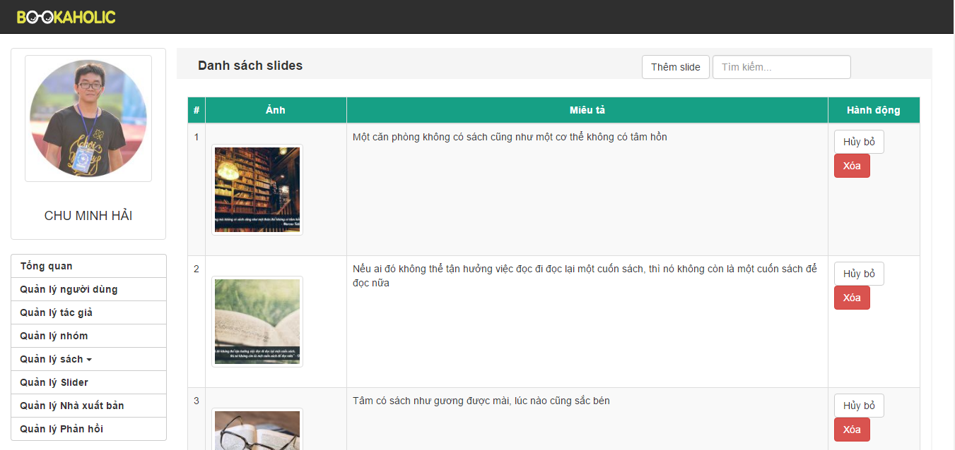

**Figure 3.6.1: Slider Management**

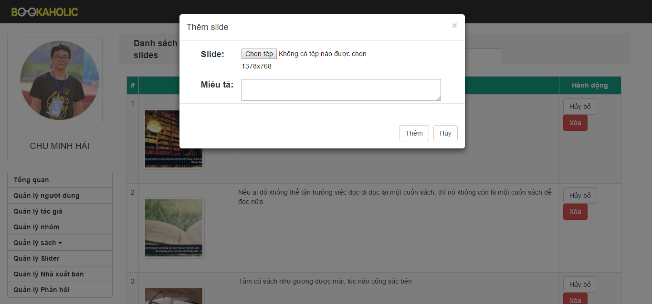

**Figure 3.6.2: Popup add slider**

|  |  |  |  |  |  |  |  |
| --- | --- | --- | --- | --- | --- | --- | --- |
| No | Field name | Field name in Vietnamese | Type | Require | Mandatory | Max-Length | Description |
| 1 | Add slide button | Thêm slide mới | Button |  | Y |  | When click the add slide button the popup will appear . |
| 2 | Search | Tìm kiếm | Textbox | Click | Y |  | Search slide |
| 3 | Popup Add Slide | Khung thêm slide | Model popup |  | Y |  | Popup appear and allow add new slide |
| Chọn file |  |  | Y |  | Allow choose file |
| Miêu tả | Text input |  | Y |  | Enter the description about the slide |
| Nút thêm | Button | Click | Y |  | When choose file and enter description, then click the add button, the slide will be added. |
| Cancel button | Button | Click | Y |  | When click cancel button, add new slide will be canceled. |
| 4 | List slides | Danh sách slide | Table |  | Y |  | List slides (image, description, on button, off button, action). |
| 5 | On button | Nút bật | Button | Click | Y |  | When click on the on button, the slide will be show in the login page. |
| 6 | Off button | Nút tắt | Button | Click | Y |  | When click on the off button, the slide will be don’t show in the login page. |
| 7 | Delete button | Nút xóa | Button | Click | Y |  | When click on the delete button, the slide will be deleted. |

**Table 3.6: Slider Management**

## Publisher management

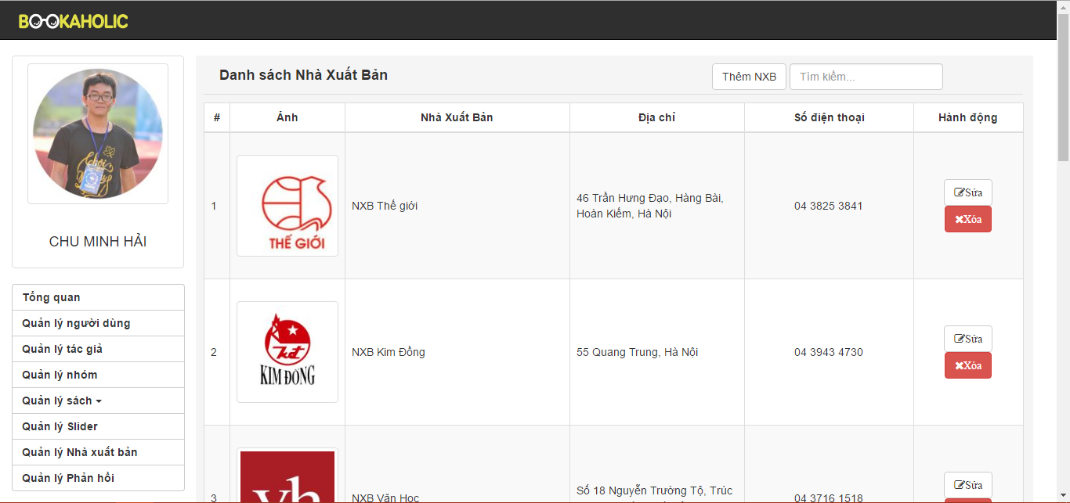

**Figure 3.7.1: Publisher Management**

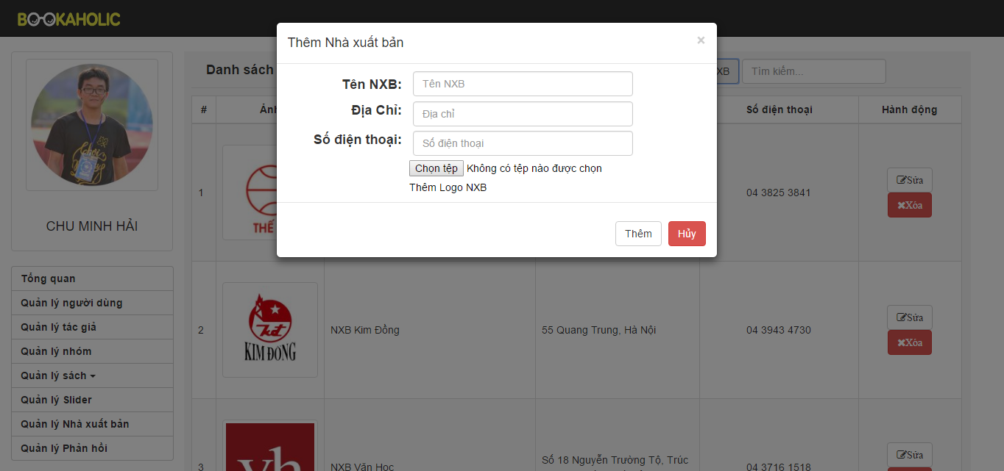

**Figure 3.7.2: Add new publisher**

|  |  |  |  |  |  |  |  |
| --- | --- | --- | --- | --- | --- | --- | --- |
| No | Field name | Field name in Vietnamese | Type | Require | Mandatory | Max-Length | Description |
| 1 | Add publisher button | Thêm nhà xuất bản mới | Button |  | Y |  | When click the add spublisher button the popup will appear . |
| 2 | Popup Add publisher | Khung thêm nhà xuất bản | Model popup |  | Y |  | Popup appear and allow add new publisher . |
| Chọn file |  |  | Y |  | Allow choose file |
| Tên nhà xuất bản | Text input |  | Y |  | Enter the name of publisher |
| Địa chỉ | Text input | Click | Y |  | Enter the address of publisher |
| Nút thêm | Button | Click | Y |  | When choose file and enter name, enter address then click the add button, the publisher will be added. |
| Cancel button | Button | Click | Y |  | When click cancel button, add new publisher will be canceled. |
| 3 | List publishers | Danh sách nhà xuất bản | Table |  | Y |  | List publisher (image, name of publisher, address). |
| Nút sửa | Button | Click | Y |  | Edit publisher’s info |
| Nút xóa | Button | Click | Y |  | Delete publisher |
| 4 | Search | Tìm kiếm | Textbox | Click | Y |  | Search publisher |

**Table 3.7: Publisher Management**

## Report management

### Report user management

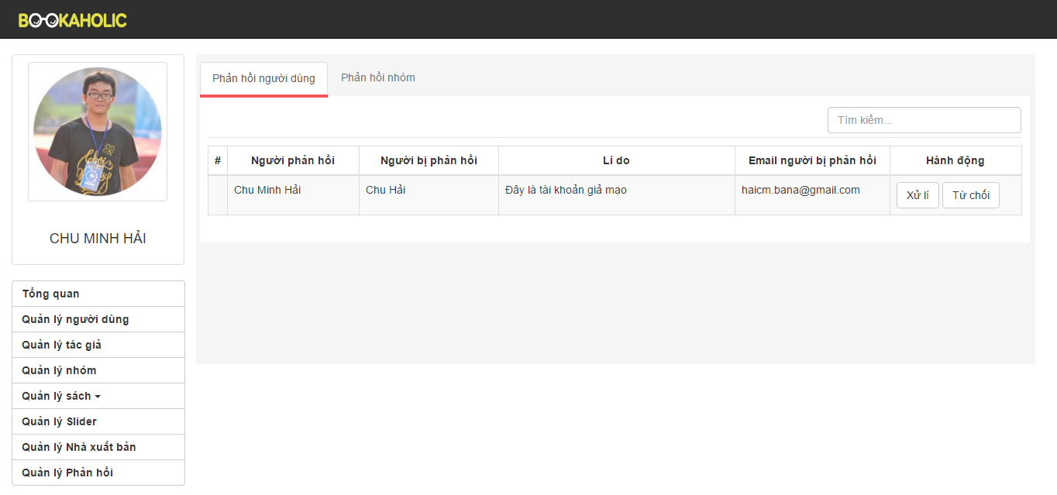

**Figure 3.8.1: Report user**

|  |  |  |  |  |  |  |  |
| --- | --- | --- | --- | --- | --- | --- | --- |
| No | Field name | Field name in Vietnamese | Type | Require | Mandatory | Max-Length | Description |
| 1 | Search | Tìm kiếm | Textbox | Click | Y |  | Search user |
| 2 | List reports | Danh sách phản hồi | Table |  | Y |  | List reports (reporter, reported, email of reported, action ). |
| 3 | Handling button | Nút xử lý | Button | Click | Y |  | When click handling button, reported user has been banned |
| 4 | Denied button | Nút từ chối | Button | Click | Y |  | When click denied button, report has denied |

**Table 3.8.1: Report user**

### Report group management

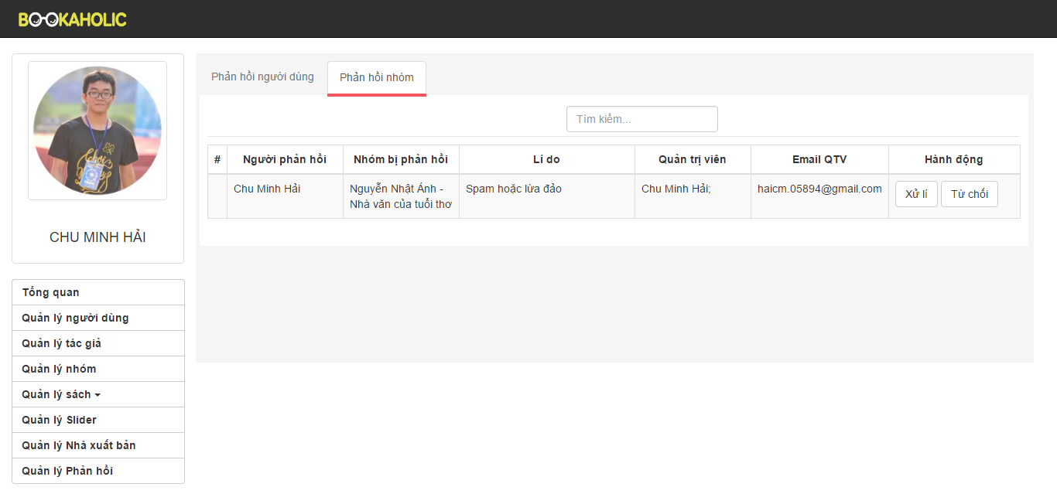

**Figure 3.8.2: Report group**

|  |  |  |  |  |  |  |  |
| --- | --- | --- | --- | --- | --- | --- | --- |
| No | Field name | Field name in Vietnamese | Type | Require | Mandatory | Max-Length | Description |
| 1 | Search | Tìm kiếm | Textbox | Click | Y |  | Search user |
| 2 | List groups | Danh sách nhóm | Table |  | Y |  | List groups (reporter, group was reported, reason,administrators, email of adminstrators action ). |
| 3 | Handling button | Nút xử lý | Button | Click | Y |  | When click handling button, reported group has been banned |
| 4 | Execute button | Nút thực hiện | Button | Click | Y |  | When click denied button, report has denied |

**Table 3.8.2: Report group**